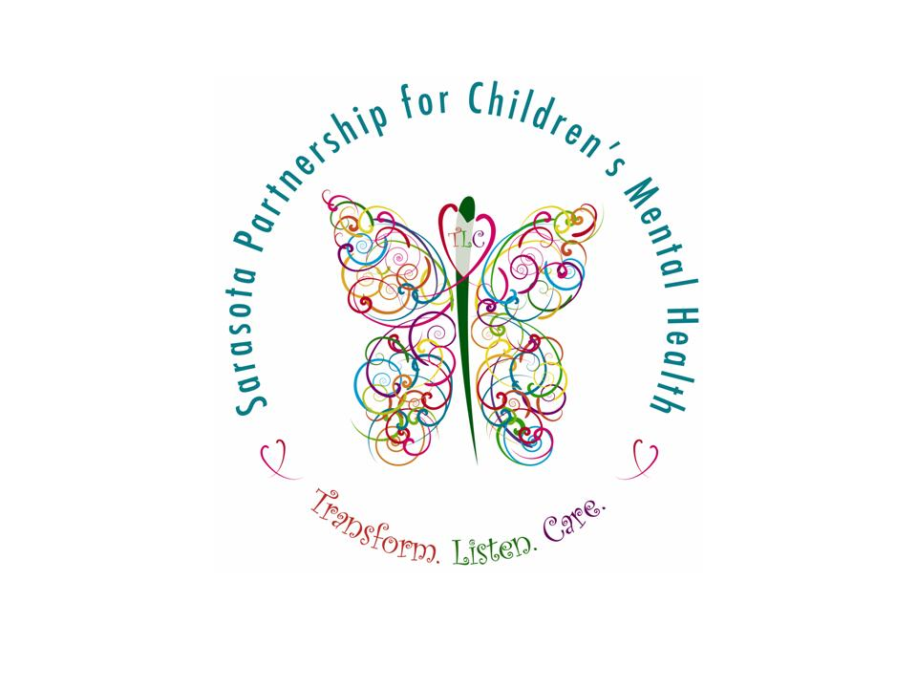
The Sarasota Partnership for Children’s Mental Health

In September 2005, Sarasota County was one of only six communities in the U.S. awarded special grant funding to focus on the mental health and social-emotional well being of Sarasota County’s very youngest residents - children from birth through eight years of age. Using the grant, successful models of care and service delivery will be introduced across current provider networks. “Wrap Around” and “System of Care” will be promoted and supported through the grant and community involvement. The grant is funded by the U.S. Department of Health and Human Services (DHHS) Substance Abuse and Mental Health Services Administration (SAMHSA).

The grant is being administrated by a team of professionals under the direction of the Sarasota County Department of Health and Human Services, with Human Services Manager, Chip Taylor, serving as the principle investigator. Meeting the challenge of creating new methods of service delivery and ensuring successful outcomes for our families will depend on the active participation of numerous community partners.

SAMHSA grant funds are intended to improve and transform children’s mental health care in local communities across the U.S. through the implementation of a “System of Care” and the “Wrap Around” process. A “System of Care” can be defined as a comprehensive array of mental and non-mental health care and services which are organized into a coordinated network to meet the multiple and changing needs of children and their families. “Wrap Around” support is family driven, strength based, culturally sensitive, and individualized to the child and their family. Natural supports and community based collaboration are emphasized in a team based approach to positive outcomes.

Families in need can be directed to the Sarasota Partnership for Children’s Mental Health for special assistance through any number of community based sources such as their child’s teacher, health care worker, daycare provider, pediatrician, religious or cultural community, or even self referral. Help through the Partnership is unlike traditional models of “case management” where social workers direct the care plan and tell the family what they need to do. Instead, families referred to the Partnership are considered the experts and help guide a personalized “team” in assessing their strengths and identifying their needs in order to develop an individualized plan. Involving families, who are naturally concerned about all aspects of their child’s development, is one reason why a “System of Care” and “Wrap Around” can be so effective.

Research indicates early intervention on behalf of young children reduces the likelihood of future social problems related to inadequate support for a child with mental health needs. Trouble in school, disrupted family relationships, drug abuse, teenage pregnancy, and even interaction with the juvenile justice system may be avoided when a child’s mental health needs are addressed. Overall, early intervention and prevention efforts are also cost effective when compared to the funds necessary to support other expensive social service programs.

Sarasota County has numerous local agencies and dedicated individuals experienced in supporting the social-emotional well being of children. The grant offers the challenge, as well as an opportunity, for all community providers to work together to form a comprehensive network that will ensure that no young child or their family “fall through the cracks” and fail to get the help they need. The grant also presents an opportunity to streamline processes, expedite assistance, and avoid costly duplication of efforts and services.

The six year grant period for the Sarasota Partnership for Children’s Mental Health is October 1, 2005 – September 30, 2011. During the grant period, the Partnership will be working with interested community members to design and establish lasting networks and collaborative alliances to support the mental health needs of local children. In addition, evaluation will play an important role in the measurement of family progress and outcomes, quality improvement and overall community success.

Sustaining “System of Care” and “Wrap Around” practices community wide will depend upon continued commitment and collaboration from current service providers and our diverse County-wide networks. In addition, public education and community outreach are important components of the grant. Efforts in this area will help to reduce the negative stigma often associated with mental health related treatment and services

If you are interested in learning more about the Partnership, “System of Care,” Wrap Around” or would like to join other community partners working to implement successful changes to the way children’s mental health has traditionally been addressed, please contact the Partnership’s office at 941-861-1457.
.




